**NAME:…………………………………………………………**

**535/1**

**PHYSICS**

**APRIL, 2024**

**2 hours**

**KAJJANSI HIGH SCHOOL**

**END OF TERM 1 ASSESSMENT 2024**

**S.4 PHYSICS THEORY**

**2 hours**

***INSTRUCTIONS***

*Attempt all questions*

*Untidy work will lead to loss of marks*

*All work must be done from the question paper provided. No extra paper for rough shall be provided.*

*Where necessary, use* 𝑔=10𝑚𝑠−2

**Turn over**

SECTION:A

1. In class with your teacher, you learnt about reflection of light

(a). State what you understand by the term reflection of light. (01 mark)

……………………………………………………………………………………………… ……………………………………………………………………………………………… ………………………………………………………………………………………………

(b)You also learnt that when light is refracted, there are two types of reflection. Give these two types. (02 marks)

……………………………………………………………………………..........…………

…………………………………………………………………………………………......

(c) During a physics lesson in class with your teacher you discussed and learnt that refraction of light has two laws which it obeys. State these laws. (02 marks)

………………………………………………………………………………………………

……………………………………………………………………………………………… ………………………………………………………………………………………………

…………………………………………………………………………………………

2. John’s parents travel by means of an aeroplane from Entebbe to Nairobi. From Entebbe airport when the aeroplane is in mid air, it moves with uniform acceleration.From Entebbe to Nairobi the aeroplane moves specifically in the eastern direction a distance of 810 km in 9 hours.

(a)State the meaning of the term uniform acceleration. (01mark)

………………………………………………………………………………………………

…………………………………………………………………………………...................

(b)What name is given to the 810 km traveled from Entebbe to Nairobi due east.

(01 mark)

………………………………………………………………………………………………

(c)Calculate the velocity of the aeroplane in 𝑚𝑠−1 (02 marks)

……………………………………………………………………………………………… ……………………………………………………………………………………………… ………………………………………………………………………………………...........

(d) State the speed of the aeroplane in ms-1 (01 mark)

………………………………………………………………………………………………

………………………………………………………………………………………...........

3. The figure below shows a velocity –time graph for a certain cyclist.

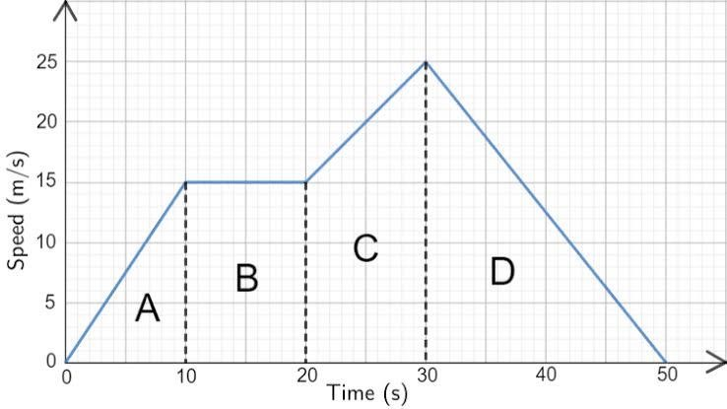

(a)Calculate the distance covered during.

(i) region A (02 marks)

……………………………………………………………………………………………… ……………………………………………………………………………………………… ………………………………………………………………………………………………

………………………………………………………………………………………………

……………………………………………………………………………………………...

(ii) region D (02 marks)

………………………………………………………………………………………………

………………………………………………………………………………………………

1. State the acceleration in region B and give a reason for your answer. (01 mark)

………………………………………………………………………………………………

………………………………………………………………………………………………

1. Describe the motion of the cyclist. (03 marks)

………………………………………………………………………………………………

………………………………………………………………………………………………

……………………………………………………………………………………………… ……………………………………………………………………………………………… ………………………………………………………………………………………………

………………………………………………………………………………………………

4. (a) Isaac Newton one of the great scientists in the world of science came up with three major laws. State the three laws and give one example where each law is applied in real

life. (03 marks)

………………………………………………………………………………………………

………………………………………………………………………………………………

……………………………………………………………………………………………… ……………………………………………………………………………………………… ………………………………………………………………………………………………

………………………………………………………………………………………………

………………………………………………………………………………………………

………………………………………………………………………………………………

………………………………………………………………………………………………

(b) Outline any four applications of the principle of conservation of linear momentum.(02 marks)

………………………………………………………………………………………………………………………………………………………………………………………………………………………………………………………………………………………………………………………………………………………………………………………………………………………………………………………………………………………………

5. (a) In senior 2 class you learnt that when a solid body is placed on a surface, it exerts pressure on that surface. State the meaning of the term pressure and its SI units.

Definition (01 mark)

………………………………………………………………………………………………

………………………………………………………………………………………………

The two SI units (01 mark)

………………………………………………………………………………………………

………………………………………………………………………………………………

(b)The figure below shows a brick of mass 6kg with dimensions 150cmx120cmx80cm placed on the table.

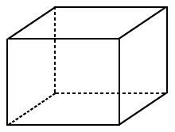

Clearly label the length, width and height of the brick on the diagram (01 mark)

(i)calculate the weight of the brick (01 marks)

……………………………………………………………………………………………… ………………………………………………………………………………………………

………………………………………………………………...............................................

(ii)The maximum pressure it exerts (02 marks)

……………………………………………………………………………………………… ………………………………………………………………………………………………

………………………………………………………………………………………………

……………………………………………………………………………………………...

(iii)The minimum pressure it exerts (02 marks)

……………………………………………………………………………………………… ………………………………………………………………………………………………

……………………………………………………………………………………………… ………………………………………………………………………………………………

…………………………………………………………………………………...................

6. A goal keeper kicked a ball vertically upwards with an initial velocity of 15𝑚𝑠−1 during a warm up training session.

1. what is the velocity of the ball at maximum height. (01 mark)

………………………………………………………………………………………………

1. Calculate this maximum height in metres (03 marks)

……………………………………………………………………………………………… ……………………………………………………………………………………………… ……………………………………………………………………………………………… ……………………………………………………………………………………………..

1. How long will it take the stone to return to the ground. (02 marks)

……………………………………………………………………………………………… ……………………………………………………………………………………………… ………………………………………………………………………………………………

………………………………………………………………………………………………

7. (a) When is work said to be done? (01 mark)

………………………………………………………………………………………………

………………………………………………………………………………………………

(b) Define the following terms

1. Kinetic energy (01 mark)

……………………………………………………………………………………………… ………………………………………………………………………………………………

1. Potential energy (01 mark)

………………………………………………………………………………………………………………………………………………………………………………………………

8. The figure below is of a father trying to open the door from his bed room.

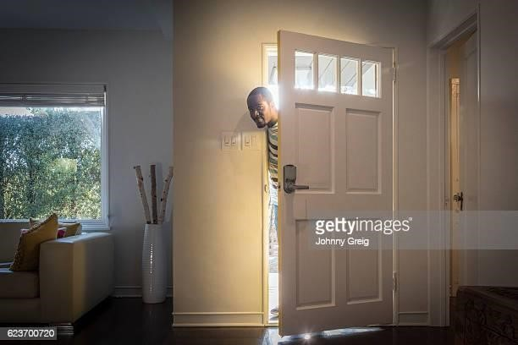

(a)Why is the handle placed at the extreme end from the hinges? (01 mark)

………………………………………………………………………………………………

………………………………………………………………………………………………

1. If the father exerted a force of 20N to open the door and the distance from the hinges to the handle is 25cm, find the moment of the force applied. (02 marks)

……………………………………………………………………………………………… ………………………………………………………………………………………………

………………………………………………………………………………………………

1. Modern buses always have their luggage packed below their seats and not on the roof

rackets, explain why this is so. (02 marks)

………………………………………………………………………………………………

………………………………………………………………………………………………

9. (a)Define the term linear momentum and state its s.1 unit. (01 marks)

………………………………………………………………………………………………

………………………………………………………………………………………………

(b)(i) Ball A of mass 400g moving with a velocity of 20𝑚𝑠−1collided with ball B of mass 50g at rest. If ball B moves with a velocity of 10𝑚𝑠−1after collision in the direction of ball A. Find the velocity of ball A after collision. (03 marks)

……………………………………………………………………………………………… ………………………………………………………………………………………………

………………………………………………………………………………………………

………………………………………………………………………………………………

………………………………………………………………………………………………

………………………………………………………………………………………………

……………………………………………………………………………………………… ……………………………………………………………………………………………..

(ii) Which type of collision was experienced in b(i) above. (01 mark)

………………………………………………………………………………………………

SECTION B

10.Ronald’s father is a builder. Last month his father was given work to build a small one room house. After building for two days the walls became higher than his height and his hands could not reach out to build on the remaining courses of bricks. Ronald came to see his father and he found him struggling. As a senior four student who studied simple machines, imagine that you are Ronald, make a write up of what you would do for your

father to solve this problem (10 marks)

………………………………………………………………………………………………

………………………………………………………………………………………………

……………………………………………………………………………………………… ………………………………………………………………………………………………

………………………………………………………………………………………………

………………………………………………………………………………………………

………………………………………………………………………………………………

**END**